**Results**

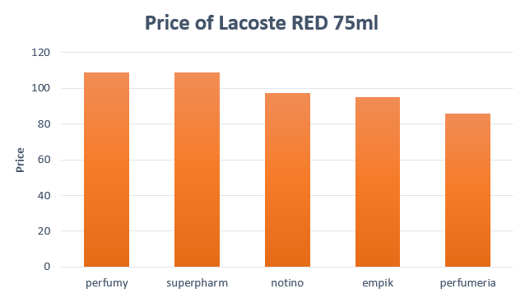

Usually the lowest prices were always on perfumeria.pl website. It was also cheaper on the empik and notino websites, which, depending on the model, turned into the positions of the cheapest leaders.

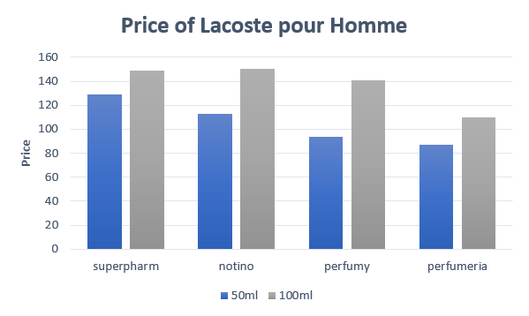

Perfume prices also depend on the size. Sometimes a store with a cheaper small perfume turned out to be more expensive with a larger capacity. Like in Superpharm and Notino.

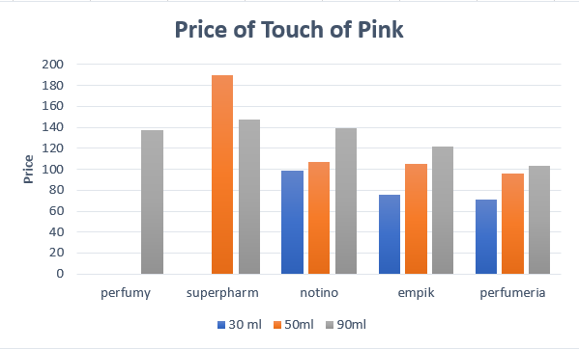

*Some columns are empty due to the lack of perfumes available in the shop

It was very rare for a perfume price to be lower for a smaller capacity in a given store. This was usually due to promotions, as in the case of Superpharm which for the Touch of Pink perfume, the price of 50 ml is over PLN 40 higher than 90 ml.

The results generated with our code are easy to interpret. Prices and products are clearly stated and described, and price filtering options were applied in order for better visualization of the data. Price comparison was the main goal we wanted to achieve in this project, as with the available variety of brands and online stores there is a high demand of product rating and price comparing options. One can easily say that the project is scalable – all it takes is the addition of various categories and other websites. As an example – a polish comparison shopping website ceneo.pl grew from 4 to 4000 categories in 13 years of its existence. Currently, it is also the second biggest e-commerce service in Poland. Nevertheless, the development of such a service can prove challenging. Our analysis focused only on 5 stores, one brand and one type of product, and yet the process of preparing the data we scraped demanded extra caution or, in some cases, fine-tuning the filtering code.